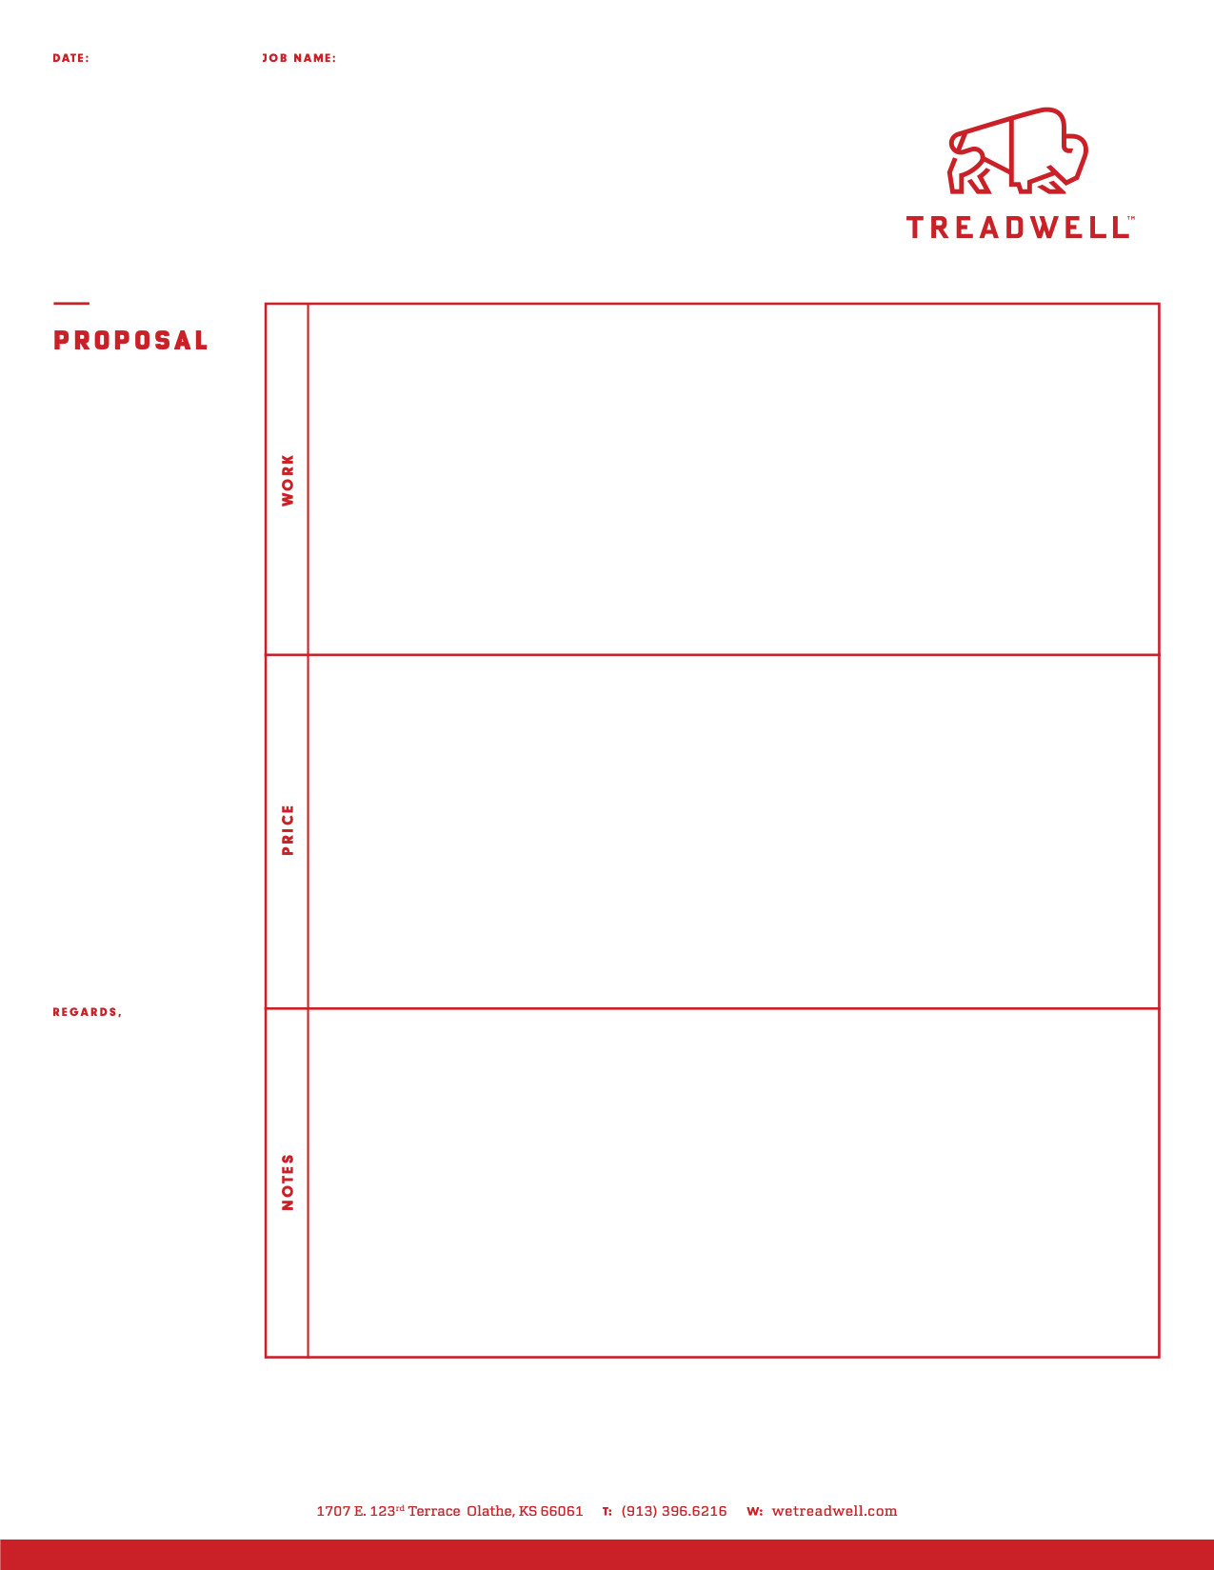
xx
xx, KS
xx, MO

5/1/26

Greg Ingebretson

Sealed Concrete: per Spec 03xx & Drawings by xx Architects dated 4/1/26 (NO spec)

- System: Clean -or- Grind and Sealed Concrete.
- Area: ~1,600 sf of sealed concrete flooring [SC] per the Finish Schedule on A900
- Scope: Prep substrate (includes patching of minor substrate defects i.e., cracks, divots, & spalls*)
Clean Concrete; -or- Perform 1-2 passes with planetary grinder -or- auto scrubber
Apply [1 coat -or- up to 2 coats of clear concrete sealer
Assumes sealer over: clean, sound & solid concrete substrate
- Schedule: [ 1 mob/phase ] Assumes all areas available at one time, approx. 1week to complete full scope
- Exclusions: Patching, Grinding, Joint Filler (see option), Polishing of Concrete, Cove Base, Dye, Demo of Existing Floor/Glue/Etc. (new slab), Excessive Patching / Grinding (no more than 1 bag per 1,000 sf, see exclusion detail below*), Mock-Up, Nights & Weekends, Removal of Existing Joint Filler (if any)

- Notes: xx

Base Bid
- $x – Sealed Concrete as described above (material sales tax INCLUDED)
- $ x – Material Sales Tax
- $ x – Kansas Remodel Tax
- $x – Total

Options & Unit Prices

- $x – Add for Joint Filler, if desired as part of this scope (excludes removal of existing, if any).
  - x
- $x – Add for

- $1,100 – Add for onsite/in place mock-up, approximately 10’ x 10’.
- $x – Add for Treadwell to install ram board protection over sealed concrete floor after completed.
Repairs and maintenance of protection by others.
- $400 /day or $1,700 /week – Add for Treadwell provided Generator, if 480 volts / 50-amp onsite power unavailable.

- Pigtail electrical connection for grinding equipment by others. See add option for Treadwell provided generator if required.
- *Excludes major floor prep/patch, demo, saw cutting, conc. repair/leveling, sloping, abatement (unless otherwise noted)
- Excludes prevailing wage (unless otherwise noted), bond & liquidated damages, credit for unused mobilizations/phases
- Excludes hoisting or lifting of equipment to elevated slabs if elevator is unavailable
- Excludes temporary/permanent lighting & HVAC as required by the manufacturer for system installation.
- Testing of floor excluded (reflectance, slip resistance, coefficient of friction, abrasion resistance, moisture, alkalinity)
- Onsite Mockup excluded (unless specially noted as included in scope above)
- Protection of new floor after install by others. See add option above for Treadwell protection.
- Treadwell recommends a pre-placement meeting with the concrete contractor. Concrete flatness, mix design & curing
process will greatly influence the final look of the concrete. Variations in aggregate exposure & color should be expected
- Add $2,300 for each additional required phase beyond above stated schedule. Excludes credit for unused mobs/phases.
- Add $500 /crew hour “show up time” if crew mobilizes at agreed upon start date & time but the job site is not ready.
- Add $500 /crew hour for “stand down time” if working, onsite crew is stopped for a reason outside of Treadwell’s control.
- Addenda Acknowledged: 0
- Treadwell typically requires 5 weeks of notice when scheduling new work
- Treadwell includes the following insurance coverage: GL: 1M/2M, WC: 1M, Auto: 1M, Umb: 5M. Additional Coverage can be
provided at an additional cost.
- Treadwell is not responsible for wear & tear to existing finishes resulting from flooring installation. See Terms & Conditions.
- Treadwell reserves the right to terminate the contract for customers not meeting Treadwell's pre-qual. requirements.
- Proposal valid for 30 days. The attached “Terms and Conditions” are part of this proposal/contract.

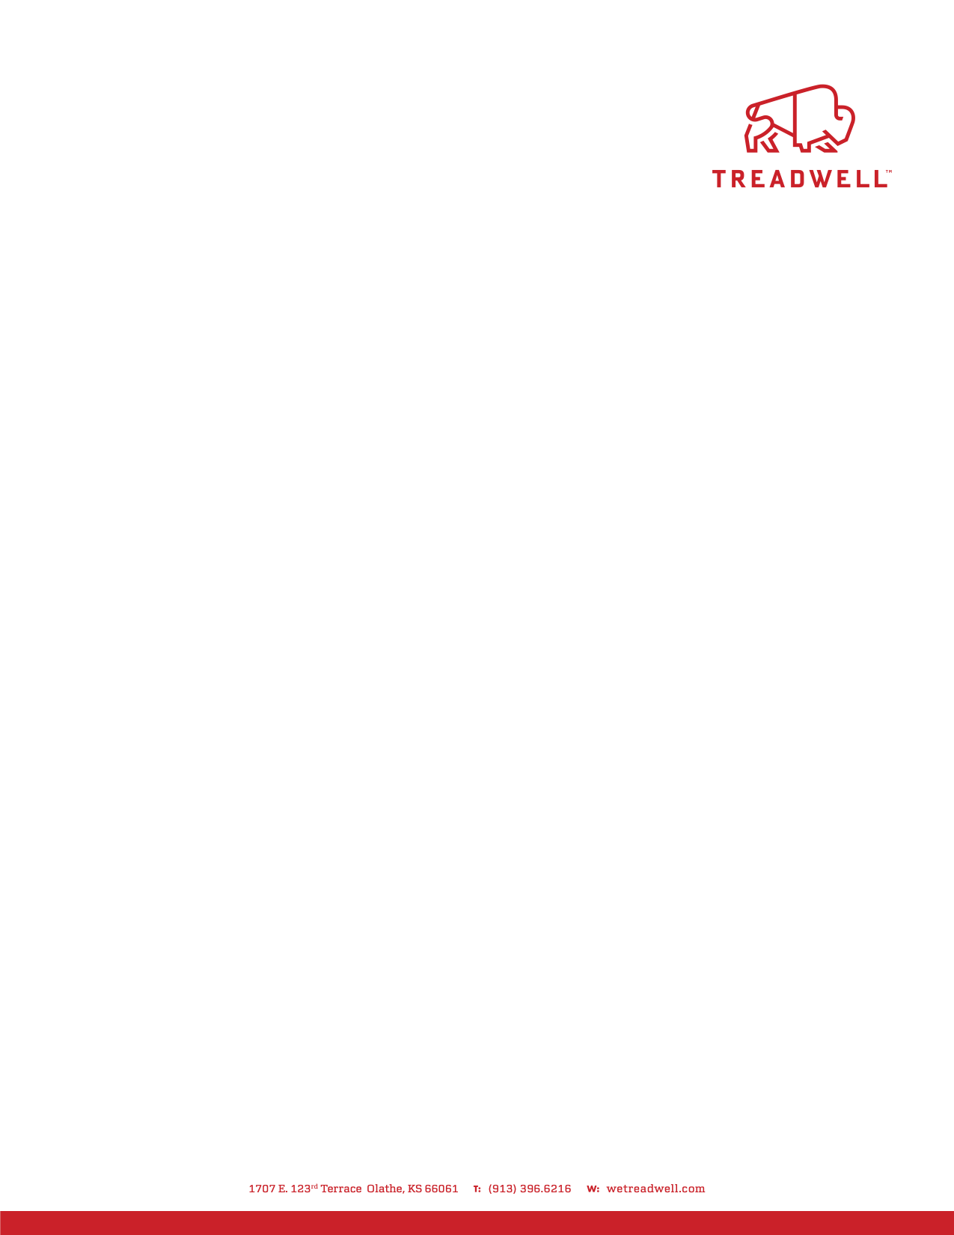
TERMS AND CONDITIONS
TREADWELL, LLC

- Agreement. The Proposal (“Proposal”) of Treadwell, LLC (“Treadwell”), which is incorporated herein, and these Terms and Conditions shall constitute the entire agreement ("Contract") between Customer and Treadwell (the “Parties”).
- Price and Payment Terms. Customer shall pay Treadwell as set forth in the Proposal (“Contract Price”) for the performance of the Work described in the Proposal. A change in the price of an item of material of more than 5% between the date of the Proposal and the date of installation shall warrant an equitable adjustment in the Contract Price.
- Nonpayment. Customer shall pay each invoice per terms noted on proposal sheet. If no terms noted, payment shall be made within ten (10) days. Treadwell shall have the right to suspend the Work if a payment is not made on time, without waiving its right to terminate this Agreement. Any overdue payment shall bear interest at the rate of 18% per annum.
- Equitable Adjustment. Treadwell shall be entitled to an equitable adjustment of the schedule and/or Contract Price, including but not limited to any increased costs of labor, supervision, equipment or materials, and reasonable overhead and profit, for any modification of the Project schedule differing from the bid schedule, and for any other delays, acceleration, out-of-sequence work and schedule changes beyond its reasonable control, including but not limited to those caused by labor unrest, fires, floods, acts of nature or government, wars, embargos, vendor priorities and allocations, transportation delays, unusual delays in delivery, suspension of work for non-payment or as ordered by Customer, or other delays caused by Customer or others. Should work be delayed by any of the aforementioned causes for a period exceeding ninety (90) days, Treadwell shall be entitled to terminate this Contract. In addition, Treadwell shall be entitled to recover its costs for extended job site general conditions due to delays caused by said events or other excusable delays.
- Change Proposals. Treadwell’s change proposals must be processed in not more than (thirty) 30 days or as otherwise indicated on the change proposal.
- Project Information. Treadwell has been provided with information and data relating to the site and details of the Project. Treadwell shall be entitled to rely on the accuracy of all such information.
- Temporary Facilities. Except as specifically required by the Proposal or documents incorporated therein, Customer shall furnish all temporary site facilities, including but not limited to site access, storage space, hoisting facilities, guard rails, covers for floor, roof and wall openings, security, parking, safety orientation, break and lunch facilities, toilet and wash facilities, drinking water and other water facilities, electrical service, telecommunication service, lighting, heat, ventilation, weather protection, fire protection, and trash and recycling services.
- Wear & Tear. Treadwell takes extra care when working in finished spaces. However, due to the types of floors we install and the equipment required there may be some wear and tear to existing finishes. Treadwell will participate in developing a plan to minimize the impacts of the flooring installation but is not responsible for wear and tear items such as dust created from concrete prep, wall and baseboard damage from equipment use, paint removal from painter’s tape, slurry runs, scratches on finishes from equipment use and splatter from mixing process
- Limited Warranty. Treadwell warrants that for one (1) year following the date of substantial completion of Treadwell's Work, it will promptly repair or replace any improper or defective workmanship or materials. This limited warranty excludes any damage or defect caused by abuse, improper or insufficient maintenance, improper operation, normal wear and tear, normal usage, or minor imperfections in the Work. This limited warranty is Customer’s sole and exclusive remedy against Treadwell under any theory of recovery for any defective workmanship or materials. This limited warranty is not transferable or assignable to any other person or entity. This limited warranty is expressly conditioned on: 1) Customer's timely payment to Treadwell of all amounts due for Work performed by Treadwell; 2) Customer's written notice to Treadwell within twenty (20) days after Customer first becomes aware of any such improper or defective workmanship (provided notice is provided within the one-year warranty period); and 3) Treadwell having had a reasonable opportunity to
inspect the alleged improper or defective work prior to any removal or alteration by Customer. Instead of repair or replacement, Treadwell may, in its sole discretion, fully and completely satisfy its obligations under this warranty by refunding to Customer the Contract Price paid by Customer.
TO THE EXTENT PERMITTED BY APPLICABLE LAW, TREADWELL HEREBY SPECIFICALLY DISCLAIMS ALL OTHER WARRANTIES, EXPRESS OR IMPLIED, INCLUDING ANY IMPLIED WARRANTY OF MERCHANTABILITY OR FITNESS FOR ANY PARTICULAR PURPOSE.



- Mutual Waiver of Consequential Damages. The Parties waive all claims against each other for consequential damages arising out of or relating to this Agreement, including, but not limited to, loss of use, income, profit, financing, business, reputation, and principal office salaries and expenses. This mutual waiver is applicable, without limitation, to all consequential damages due to either Party’s termination in accordance with this Agreement.
- Limitation of Liability. Notwithstanding any other provisions of this Agreement to the contrary, in recognition of the relative risks and benefits of the Project to the Parties, and to the fullest extent permitted by law, the total liability in the aggregate of Treadwell and its officers, directors, employees, agents, subconsultants and subcontractors, and any of them, to Customer and any one claiming by, through or under it, for any and all damages, injuries, claims, losses, expenses, or damages whatsoever arising out of in any way related to Treadwell’s Work, the Project, or this Agreement, from any cause or causes whatsoever, including, but not limit to, negligence, gross negligence, errors, omissions, strict liability, breach of contract, contribution, and misrepresentation, shall i) for events covered by insurance, not exceed the limits of the insurance maintained by Treadwell pursuant to this Agreement, and (ii) for events not covered by insurance maintained by Treadwell, not to exceed the Contract Price. The Parties acknowledge that sufficient consideration has been provided for this limitation.
- Indemnity. To the fullest extent permitted by law, Customer shall defend, indemnify and hold harmless Treadwell and its officers, directors, employees, agents, subconsultants, and subcontractors, and each of them, from and against all claims, causes of action, damages, losses and expenses, including but not limited to attorneys’ fees, expenses, and expert fees, to the extent caused by the negligence of or breach of the Agreement by Customer or anyone for whose acts it may be liable (including but not limited to, losses or claims resulting from the improper operation or maintenance of the equipment), regardless of whether or not such claim, damage, loss or expense is caused in part by Treadwell or other party indemnified hereunder.
- Insurance. Treadwell will maintain Commercial General Liability insurance with limits of liability of at least $1,000,000 per occurrence and $2,000,000 in the aggregate, Comprehensive Automobile Liability Insurance with limits of at least $1,000,000 per accident, and Workers’ Compensation insurance as provided by law. Treadwell shall not participate in any consolidated insurance program (“CIP”).
- Waiver of Subrogation. To the extent that damages are covered by any property insurance maintained during or after the completion of the Work, Customer waives all rights, including rights of subrogation, against Treadwell and its employees, subcontractors, and suppliers.
- Termination. If either Party materially fails to perform in accordance with the terms and conditions of this Agreement, including, but not limited to, failing to pay the Contract Price as provided above, the other Party may initiate termination by issuing a Notice of Proposed Termination to the breaching Party. If the default is not cured within seven (7) days after receipt of such Notice, this Agreement may be terminated by the issuance of a Notice of Termination to the defaulting Party. If Treadwell is entitled to terminate, it shall be entitled to recover from Customer for Work executed and for proven loss with respect to tools, and construction equipment and machinery, including reasonable overhead, profit, and damages.
- Claims. Any claim against Treadwell shall be asserted in writing within twenty (20) days after the event giving rise to the claim, or the claim shall be deemed to have been waived.
- Nonbinding Mediation. Any claim arising out of or related to this Agreement shall be subject to mediation as a condition precedent to binding arbitration. Unless the Parties otherwise agree, the mediation shall be administered by the American Arbitration Association (“AAA”) in accordance with its Construction Industry Mediation Procedures in effect on the date of this Agreement. The request may be made concurrently with the filing of arbitration but the mediation shall be concluded before the arbitration. The Parties shall equally share the mediator’s fee and any filing fees. The mediation shall be held in Johnson County, Kansas.
- Binding Arbitration. Any claim arising out of or related to this Agreement that is not resolved by mediation shall be subject to binding arbitration, which, unless the Parties otherwise agree, shall be administered by the AAA in accordance with its Construction Industry Arbitration Rules in effect on the date of this Agreement. A demand for arbitration shall be made in writing, delivered to the other Party, and filed with
AAA. The Party filing a notice of demand for arbitration must include all claims then known to that Party that are subject to arbitration. A demand for arbitration shall be filed with the AAA before the date when



the filing of a lawsuit based on the claim would be barred by the applicable statute of limitations or statute of repose, whichever is shorter. If Treadwell is the prevailing party in any proceeding between
the Parties arising out of or related to this Agreement, it shall be entitled to recover its reasonable attorneys’ fees, expenses, expert fees, the fees of the arbitrator(s), and the administrative expenses of the AAA.
- Governing Law. This Agreement shall be interpreted in accordance with and governed by the laws of the state of Kansas, without regard to that state’s rules on conflicts of laws.
- Modification. No modification or amendment to this Agreement shall have any force or effect unless mutually agreed to in a writing signed by both Parties.
- Binding Effect. This Agreement is binding upon the Parties and their successors, assigns, and related entities.
- Entire Agreement. This Agreement contains the entire agreement of the Parties and there are no other oral, written, express or implied promises, agreements, representations, or inducements not specified in this Agreement. The Parties also agree that all the terms of this Agreement are contractual and not a mere recital.
- Severability. In the event that one or more of the provisions in this Agreement are, for any reason, held to be invalid, illegal, or unenforceable in any respect, such invalidity, illegality, or unenforceability shall not affect any other provision of this Agreement.
- Third Parties. This Agreement shall not be construed to create a contractual or third-party beneficiary relationship of any kind with any third party.
- Assignment. Neither Party shall assign the Contract, in whole or in part, without the written consent of the other.
- Notice - Kansas Project: Kansas law contains important requirements you must follow before you may file a lawsuit for defective construction against the contractor who constructed your home. Ninety days before you file your lawsuit, you must deliver to the contractor a written notice of any construction conditions you allege are defective and provide your contractor the opportunity to make an offer to repair or pay for the defects. You are not obligated to accept any offer made by the contractor. There are strict deadlines and procedures under state law, and failure to follow them may affect your ability to file a lawsuit.
- Notice - Missouri Project: FAILURE OF THIS CONTRACTOR TO PAY THOSE PERSONS SUPPLYING MATERIAL OR SERVICES TO COMPLETE THIS CONTRACT CAN RESULT IN THE FILING OF A MECHANIC'S LIEN ON THE PROPERTY WHICH IS THE SUBJECT OF THIS CONTRACT PURSUANT TO CHAPTER 429, RSMO. TO AVOID THIS RESULT, YOU MAY ASK THIS CONTRACTOR FOR "LIEN WAIVERS" FROM ALL PERSONS SUPPLYING MATERIAL OR SERVICES FOR THE WORK DESCRIBED IN THIS CONTRACT. FAILURE TO SECURE LIEN WAIVERS MAY RESULT IN YOUR PAYING FOR LABOR AND MATERIAL TWICE.

